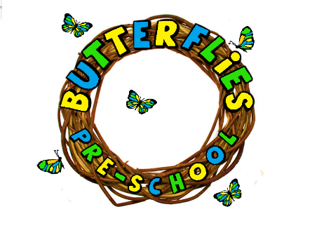LARGE PLAY EQUIPMENT POLICY

The safety of each child is paramount, and we will always strive to ensure that the children are kept safe while they learn to master each piece of equipment, so that they can enjoy all that physical play has to offer. This type of play allows children to explore and find their own boundaries in a safe environment with supportive practitioners.
Physical play is an essential part of a child’s development; therefore, this type of play is provided daily. We risk assess all equipment regularly and on outings, its risk assessed before any children are allowed to enter. This meets the safeguarding requirements of the EYFS.
EYFS Requirements
Providers must provide access to an outdoor play area or if that is not possible ensure that outdoor activities are planned and taken on a daily basis.
The large play equipment in the hall is checked before use to ensure that it is safe for the children to use at all times.
The children are encouraged to use this equipment and assistance is available should they require it. We make all play equipment accessible to children with learning and disabilities. Please see SEND policy.
Outings to the park will also involve the children using large play equipment and we will always carry out a full risk assessment before the children are allowed to access this apparatus. Please see outing policy.
We obtain parental permission at the enrolment process. This includes for outings.

REVIEWED: 10/11/2023 LEANNE COLES BUTTERFLIES PRE-SCHOOL

