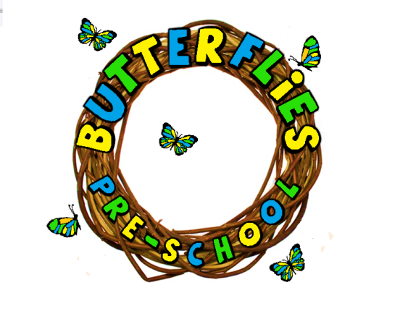

**HYGEINE POLICY**

We recognise the importance to preventing the spread of germs and illnesses. Hygiene Procedures are strictly adhered to minimise the risks posed to.

I strictly adhered to minimise the risks passed to children, staff, and visitors.

We expect staff, parents, carers, and children are aware of and follow hygiene procedures.

The children are encouraged to wash their hands after using the toilet, before handling or eating food, blowing noses, changing inside and outside.

Children are shown the importance of good hygiene practice through systems and our curriculum.

We use disposable paper towels to dry their hands after washing to prevent cross infection.

Hand sanitiser are available at tissue stations.

Tissues should be safely disposed of promoting catch it, bin it, kill it approach.

We will assist children to wipe their noses and teach them to dispose of the tissue responsibly. Bins will be provided in the hall for children to do this.

Should a child’s face need cleaning we will use a flannel. These flannels will be used only once for each child and washed daily.

When dealing with spillages such as blood, vomit, urine and faeces, gloves and apron will be worn to clean it up immediately, the area will be disinfected and dispose of safely and hygienically. The children will be kept away while such substances are being dealt with.

We follow strict hygiene routines in the kitchen, ensuring that the fridge is kept at the correct temperature and that food is stored safely, following guidelines from the Food Standards Agency.

All paperwork involving Health and Safety will be done by Vikky Mawdsley.

We will keep up to date with food hygiene issues by attending relevant training.

Food storage will be regularly and thoroughly cleaned.

We will disinfect the changing mat after each nappy change and the potties and toilet seat after each use.

The bathroom area is checked and cleaned before, during and after session.

We ask staff and parents to ensure clothes are changed daily and washed on a 60 wash.

When using first aid we ensure a high standard is used when administering and treatment to children or other staff. We will wash hands before and after treatment and use disposable gloves. Waste will be disposed of safely and all bins will be emptied when needed.

Uxbridge Community Centre organise a cleaner 3 times a week to include all areas, toilet, kitchen, and nappy changing areas.

All toys and resources are checked daily and is always cleaned and appropriate for use.

Sensory resources for the mess play are checked and changed regularly.

Please note we use this policy alongside the Health and Safety Policy.

**AMENDED: 25/10/2023 LEANNE COLES** **BUTTERFLIES PRE-SCHOOL**